A number spiral is an infinite grid whose upper-left square has number 1. Here are the first five layers of the spiral:

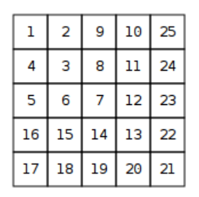

Your task is to find out the number in row y and column x.

**Input**

The first input line contains an integer t: the number of tests.

After this, there are t lines, each containing integers y and x.

**Output**

For each test, print the number in row y and column x.

**Constraints**

* 1 ≤ t ≤ 105
* 1 ≤ y , x ≤ 109

**Example**

Input:

3

2 3

1 1

4 2

Output:

8

1

15